Theo's Grandma's Traditional
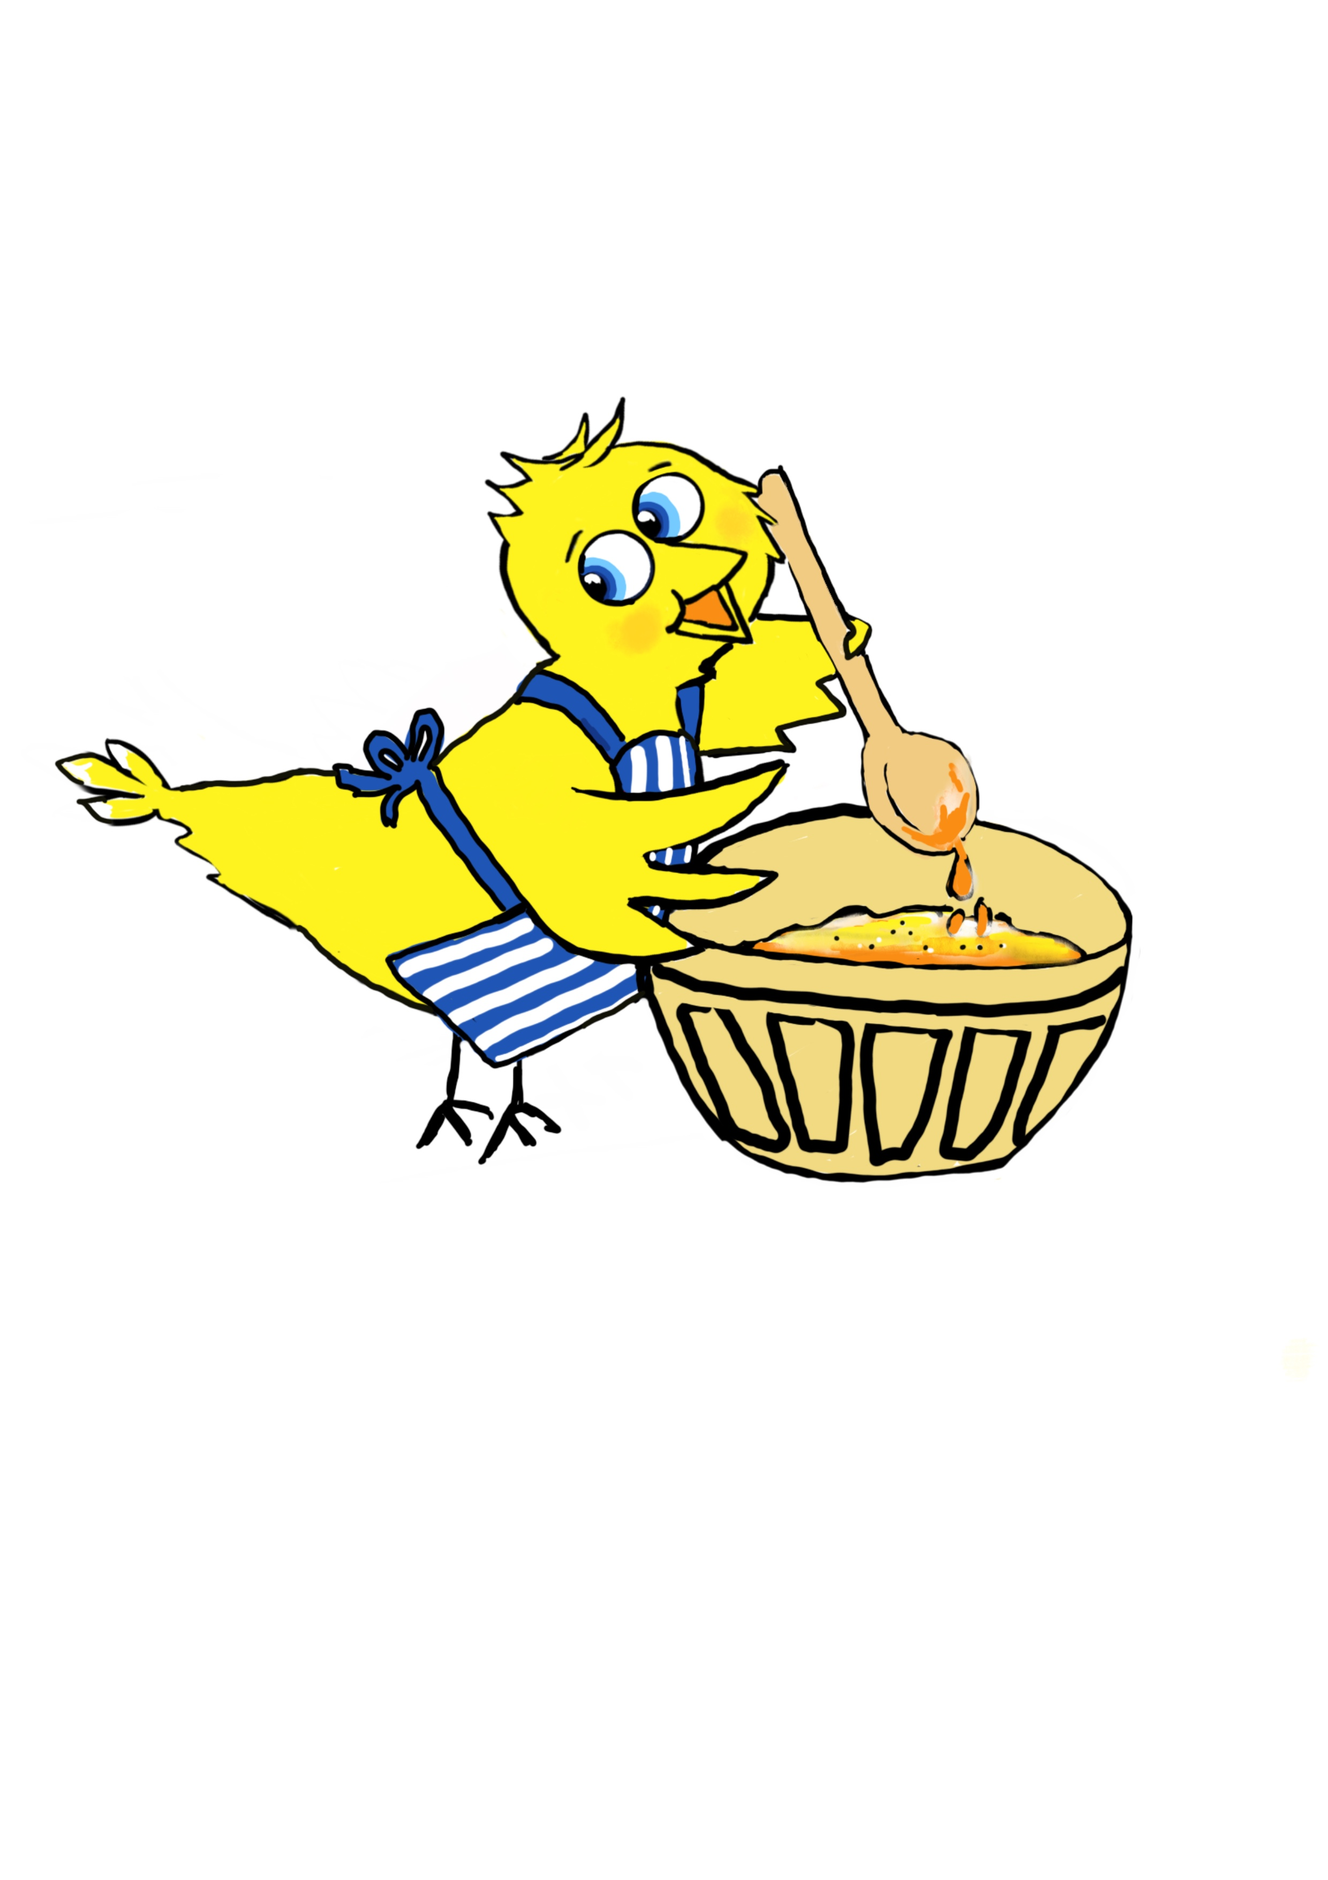
Welsh Cake Recipe
Ingredients
- 225g self-raising flour
- 125g Stork Margarine or unsalted butter
- 75g caster sugar
- 75g sultanas
- 1 large egg, beaten
- A good pinch of mixed spice
You will need a grown up to cook them for you. Please do not try to cook them yourself
How to Make Welsh Cakes – It's time to get your hands messy!
- In a large mixing bowl rub the flour, spice and butter together until it comes together like breadcrumbs.
- Stir in the caster sugar and sultanas.
- Make a well in the middle of the bowl and add the beaten egg. Keep mixing until you have a firm ball of dough; if it’s too dry, add a dash of milk.
- Roll dough on a clean floured surface, until it’s about 1cm thick; using a pastry cutter to cut out Welsh cakes.
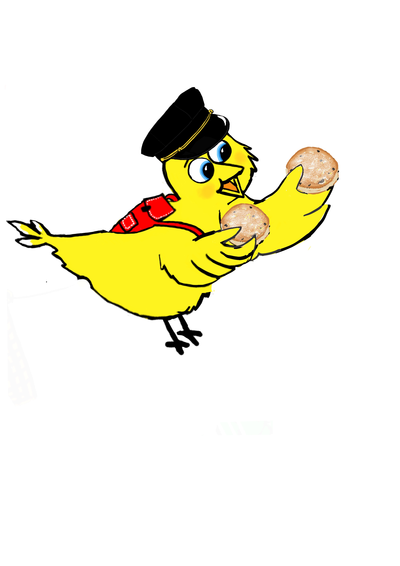
- Get a grown up to put bakestone/ Flat Plate onto a medium heat, make sure it's hot then add a little bit of butter.
- Gently place the Welsh cakes on the bakestone to cook, leave for about 3-5 minutes on each side until they are golden-brown colour and the sultanas start to sink.
- As soon as they come off the bakestone, you can dust them with caster sugar and then place on a rack to cool down.
- They are delicious and won't last very long, ideal for your lunch boxes to take to school and teachers like them too with a cup of tea.
For Gluten free. Change the flour to Gluten Free flour and add ½ tsp of xanthan gum.
Vegan/Dairy Free Replace butter with a dairy free spread, Replace Egg with a dash of dairy free milk.
Dawn Bosley Publishing- Theo The
Yellow Bird - Series 2 Book 1 My Adventure to the Ffestiniog Railway

