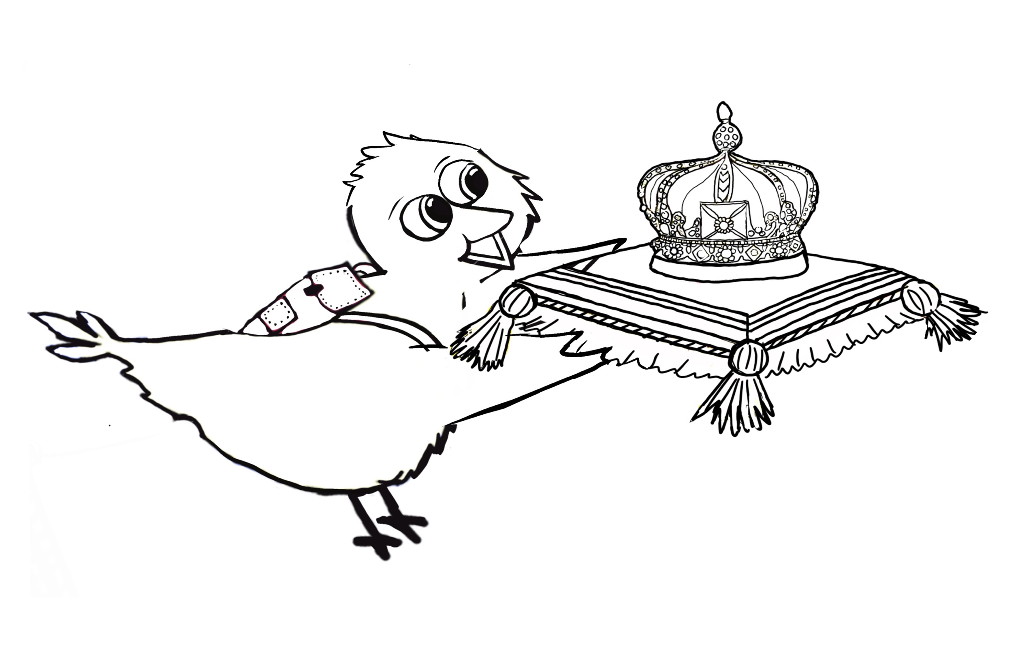

All my books, free music and activities can be found on my website www.theotheyellowbird.com



'Theo The Yellow Bird'

Children's Adventure Story books with free music

Kings Coronation Colouring Page

Lots of love Theo xx



All my books, free music and activities can be found on my website www.theotheyellowbird.com